**Structure-Texture Decomposition of Images with Interval Gradient**

Name: Yishuo Wang ID: 108533945

**Project Topic:**

In this project, I will work on “Structure-Texture Decomposition of Images with Interval Gradient”, which will decompose an image into structures and textures and take the textures away. For the result, we will filter out textures from images and get a new smooth image.

**Project Introduction:**

In the project, the contribution is two-fold.

First, we define a new type of gradient operator, called the “interval gradient”. We will propose a gradient rescaling method based on the interval gradient to suppress transform of textures while preserving the transform of structure for each pixel.

Second, we propose a novel gradient-based image filtering method that is suitable for structure-texture decomposition. After filtering the image, the results resemble the input images and at the same time preserve strong edges and gradients precisely, while detailed texture are removed. Here is the sample.

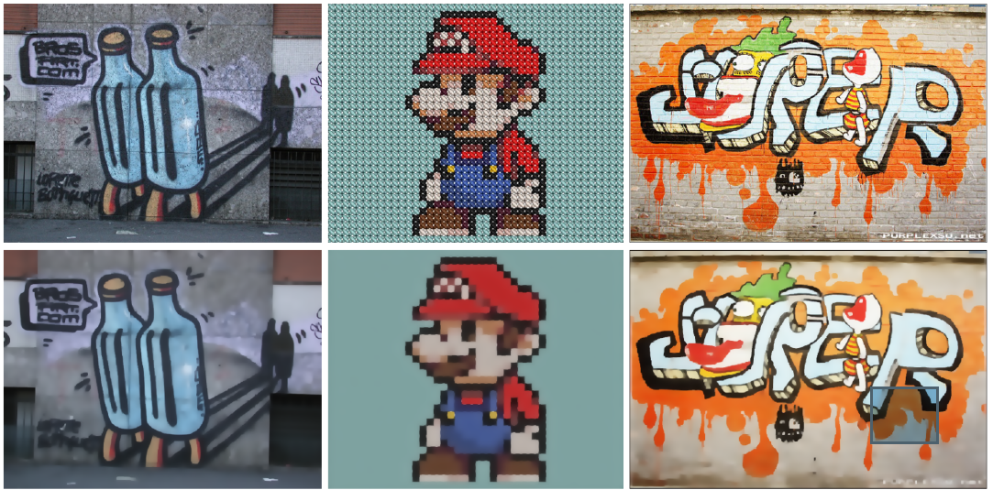

Top is the input, and bottom is the output.

**Weekly Schedule:**

1. Week 1-3: Learning the “Structure-Texture Decomposition of Image” by studying this paper and related paper.
2. Week 4-5: Learning the related Mathematic theory and try to start the project code programming.
3. Week 6-7: Try to finish the first contribution of the project, and prepare for the midterm demo presentation.
4. Week 8-9: Focus on the project coding, try to finish the project and get the correct result.
5. Week 10: Doing the final debugging. Write the final report and prepare for the final demo presentation.

**Reference**:

1. Hyunjoon L, Junho J, Junho K, Seungyong L.: *Structure-Texture Decomposition of Images with Interval Gradient*. Computer Graphics forum. (2016)
2. Agrawal A, Raskar R.: *Gradient domain manipulation techniques in vision and graphics.* In Proceedings of ICCV 2007(Tutorials, Rio dejaneiro, Brazil, 2007)
3. He k, Sun J, Tang X.: Guided image filtering. *pami* *35,* 6(2010). 1397-1409.